**Options II**

**Sessions 4-6 notes**

**Nomenclature**

|  |  |  |
| --- | --- | --- |
| **#** | **Definition** | **Meaning** |
| **1** | **Historic Volatility (HV)** | Movement of stock exhibited by stock in past few weeks / months / years. What is seen in read view / history of stock. Do not focus on HV much. IV is more important than HV. |
| **2** | **Implied Volatility (IV)** | Expected movement of stock that can be effected by upcoming ER or company news or sector news or macroeconomic trends and so on. What is expected ahead / guestimate.  Derived from option premiums. Focus on IV. If IV is high, options are expensive hence selling options is better. If IV is low, options are cheap hence buying options is better. |
| **3** | **Less Volatility** | No move expected => options will be cheaper |
| **4** | **Vega** | Vega determines how much option will change for each 1% change in IV. Vega and IV are two different things but related. |
| 5 | **IV Data Tracker** | <http://www.ivolatility.com/options.j?ticker=GOOG> |
| 6 | **Inverted Yield Curve** | Most reliable indicator of upcoming market reversal. NY Federal Reserve has a dedicated website to track this to let institutions know when things are becoming bears. Retail investors are not informed on this. So, its due to your own education.  Inverted => Short term interest rates are higher than longer term interest rates.  Inverted Yield Curve that indicates upcoming recession =>  <https://stockcharts.com/freecharts/yieldcurve.php> |
| 7 | **Shiller P/E** |  |
| 8 | **Position Size** | Keep the maximum loss to 1000$ for directional trades and 2000$ for non-directional trades like iron condors. Keep the ratio as 1:5 as probability of success for non-directional is more. If directional does better in a month, that will offset the non-performance of non-directional |

1. Big institutes place orders in bulk to take advantage little differences in volatility without having downside risk.
2. [www.ivolatility.com](http://www.ivolatility.com)
3. Whats the downside protection for 401K? Buy SPY long term PUTs.
4. Best time to buy insurance is when market is at all time high. Not when fire is 100 yards away from house / portfolio / bear market.
5. When yield curve gets reversed, short term interest rates become higher than long term interest rates. In 2007, money market funds paid 5.5% to 6%. In such scenarios, people take out money from stocks and invest in money market funds as they are risk-free.
6. Inverted yield curve once it happens as inverted, it takes 6-18 months for market to enter into bear market.
7. Make sure IV of SPY is low as options will be cheaper.
8. Keep the time to be at least 3 months. Without that, stock will not have ample time to make big moves and time decay will be less. Remember time decay grows in increasing order as expiry date is very near by.

**Long Straddle**

1. It’s a V shaped strategy.
2. Buy Call and PUT with same strike (at the money in general) at the same expiration
3. On a scale of -3 to +3, stock is expected to move -2 / -1 / +1 / +2
4. Enter 3-8 weeks prior to major event like ER.
5. Look for stocks that are > 30
6. Have history of moving 15% or -15%
7. Net Delta <= 0.05. Remember delta of PUTs are negative.
8. Go to [www.finviz.com](http://www.finviz.com)
9. Go to screener => All => Set filters for Price > 30, Average Volumn > 500K, Volatility > 6%, Optionable



Lower Breakeven = Stock price – Cost of the trade

Upper Breakeven = Stock price + Cost of the trade



**Volatility Docs**

<https://www.bloomberg.com/view/articles/2014-06-09/the-vix-is-not-a-great-way-to-measure-complacency>

<http://www.ivolatility.com/news/Volatility_to_work.pdf>

**Long Strangle**

1. Similar to Straddle but different strikes on call and PUT with same expiration
2. Breakeven are apart from each other
3. Costs lesser than straddle
4. On a scale of -3 to +3, stock is expected to move -2 / -1 / +1 / +2
5. Enter 3-8 weeks prior to major event like ER.
6. Look for stocks that are > 30
7. Have history of moving 15% or -15%
8. Net delta of call and PUT should be <= 0.05
9. Delta on each leg should be >= 0.25
10. Option price is dictated by 3 dimensions namely delta, theta and vega / IV.



Its combination of buy PUT and buy call at different strikes

Lower B / E = Lower Strike – Cost of the trade

Upper B / E = Upper Strike + Cost of the trade

* Nine out of 10 times, strangles perform better than straddles as they are cheaper and probability of success is not very different.
* Keep stock price 30-70 range to keep costs less.
* **Foreign stocks has more volatility risk due to currency rate fluctuations**

**Exit Criteria for Long Strangle**

* You are in profit before earnings. IV is still high => Exit to lock the profit unless you are sure on ER. You will miss on potential gap but you are playing safe. If call is lots in profits, may be just close call side leg and leave PUT side leg. If company tanks after ER, PUT can make money. On the other hand, if stock feel too much until ER, PUTs are lot in profits. Close the profits on PUT side and leave call side alone. If some nice up jump happens on ER, call could get some money.
* News is out but stock didn’t move wildly as expected => Exit the trade to get refund on time / extrinsic value
* Close one side leg out if lot of time left and it can move back to other leg side. Like TSLA moving from 380 to 260 in a matter of 6 weeks
* Stock has history of moving after news but it didn’t budge this time after the news is out => Exit

**Long Strangle Example:**

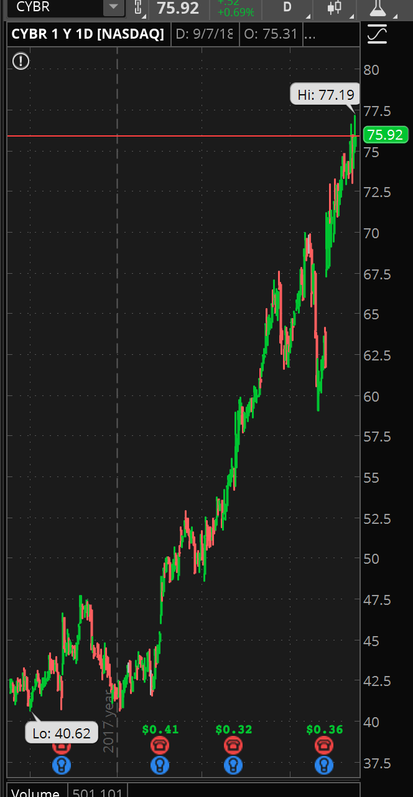

CYBR @ 75.92 on 9/9/2018

Pick buy PUT 70 strike exp Jan 2019 with delta of 0.3. Correspondingly pick buy CALL85 strike same exp with delta 0.34 to keep net delta 0.04. (Remember rule is max net delta is 0.05). Total cost 675.

Half way thru contract (11/16/2018), breakeven are 65.43 and 87.46. (Use Set Slices to Breakeven to mark them easily on modeled date to see the numbers on chart)

Max Gain = Unlimited

Max loss = Net debit of 675 if CYBR is between 70 and 85 at expiration.

Break even at expiration = 63.25 and 91.75

**Exit Plan:**

1. Position size = Max loss we can tolerate / total cost = 500 / 657 = almost 1 contract
2. Model thru half way in the expiry and decide and leave if in profits or no move is certain

**Short Strangle**

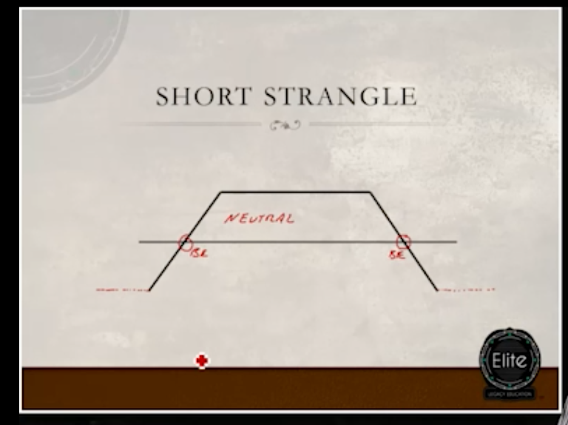

1. **Short Strangle = Sell PUT + Sell CALL**
2. **Its like iron condor without insurance.**
3. **Outlook neutral ( -1 to 1). Net credit is greater than iron condor due to lack of not buying insurance.**
4. **Risk is unlimited as it does sell call and sell PUT**
5. **Probability of success = 1 – (delta of call + delta of PUT). Go with too far OTM on lower priced stock.**
6. **Breakeven:**
   1. **Call strike + total cost**
   2. **PUT strike – total cost**
7. **Delta neutral, positive theta, negative vega, negative gamma**
8. **Don’t hold thru earnings as its negative veg**
9. **VIX is cheap = Options are cheap = Not good for short strangle**
10. **Use Iron Condor for stocks that are higher than 100$.**

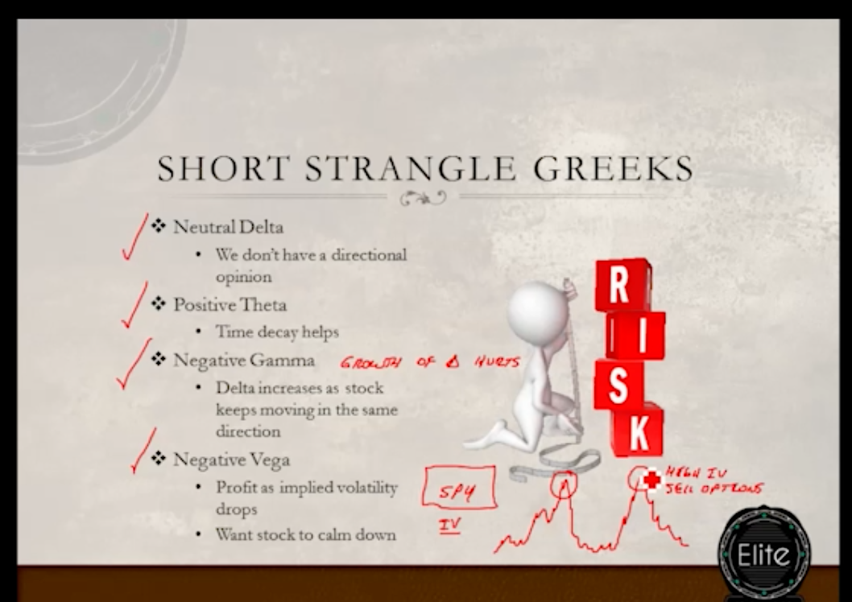

1. **Exotics are options on options. Banks do trade them privately**
2. **VIX is implied volatility. Doing options on VIX is like IV on IV.**
3. **When VIX is too low, PUTs are cheap and calls are expensive. When VIX is too high, PUTs are expensive and calls are cheap.**
4. **Ideally stick to net delta of 0.1 to 0.15.**
5. **Short call strike should be above resistance and short PUT strike should be below support.**

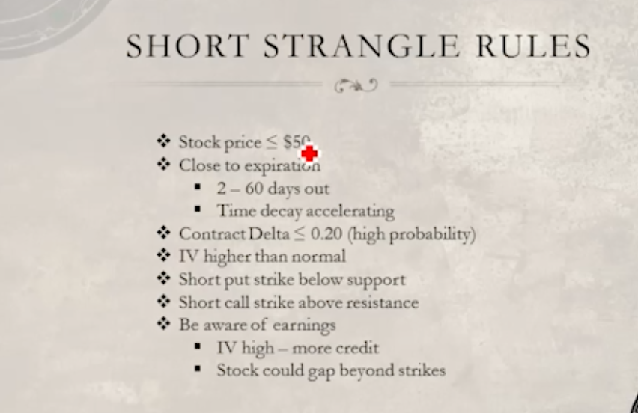

1. **Margin requirements for short strangle dynamically changes as stock price moves closer to one of the strikes. Worst case event happened with others is someone moving from 900K to 100K in 2 days. This speaks volumes about why iron condor is better than short strangle.**
2. **If you don’t plan for unexpected, and UNEXPECTED DOES HAPPEN, it can swallow the portfolio. Always, plan hedge.**
3. **Keep the position size small for short strangle and never place too many trades. Reminder : Margins change dynamically for short strangle.**

**Calendar Spreads**

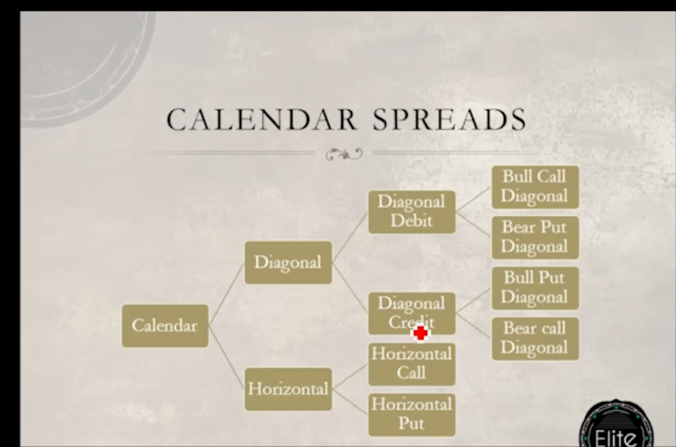

**Bull Call Diagonal Calendar Debit spread:**

1. **Buy a long term call that is ITM and sell a short term call that is OTM**
2. **BTO long term (2 to 12 months out longer the better) + STO near term**
3. **Sell contract premium >= 10% of long contract premium**
4. **Try to enter when IV is low**
5. **1-year long on BUY is better**
6. **ETFs like IWM, SPY, TLT, TBT and QQQ are good candidates**
7. **Don’t hold thru ER**
8. **Pick call of delta <= 0.2 to keep the probability of success 80%**
9. **Exit plan**
   1. **If its in ITM, BTC the call**
   2. **Let the near term sell call expire**
   3. **STO again for delta of <= 0.2 if original long call is not expiring in 2 months. Else, time decay eats up the value**

**Horizontal Call**

* + 1. **Same as diagonal call (in the sense different exp dates) but same strike rate**

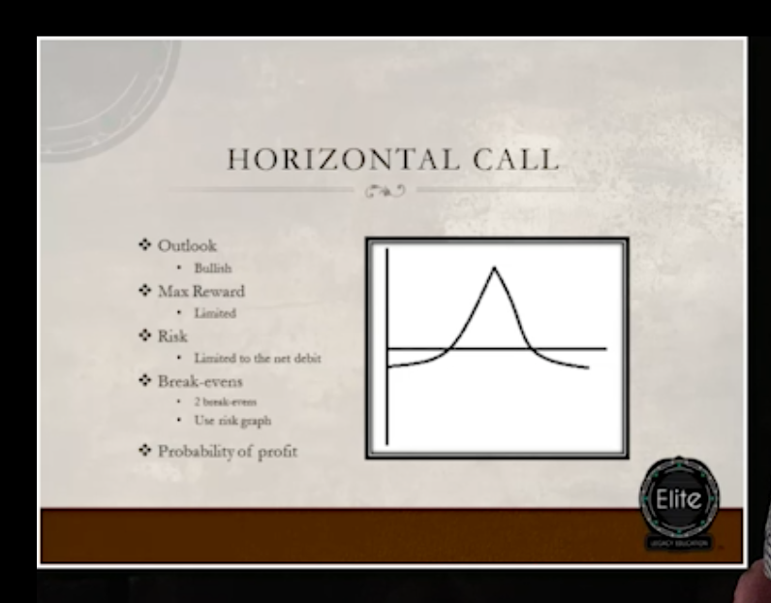

* + 1. **Cheaper than diagonal spread**
    2. **Contains 2 break events**
    3. **Use risk graphs**
    4. **Probability of profit = 20-30%**
    5. **Bull PUT and horizontal call are 2 most common successful strategies people use. Whats the catch? What do I don’t know?**
    6. **Bull call spread needs quick move for success. Horizontal call is little more forgiving even if stock takes longer to make upside move.**
    7. **Keep the sell and buy months close to each other and it reduces cost by half but increases ROI. But HOW DO WE PLAY THIS AS LONG TERM CALL?**
    8. **BTO 2-3 months and STO 2 days – 2 months. Do this when VIX is low**
    9. **Short contract premium >= 10% of long contract premium**
    10. **Close both contracts on near term STO to play it safe.**
    11. **There should not be any ER in between STO and BTO dates.**
    12. **On Bullish stocks, Horizontal call really gives nice ROI even before expiry.**
    13. **Replace stop loss with news reading, position sizes and chart reading and proper strategy based on technicals and fundamentals and right time periods.**

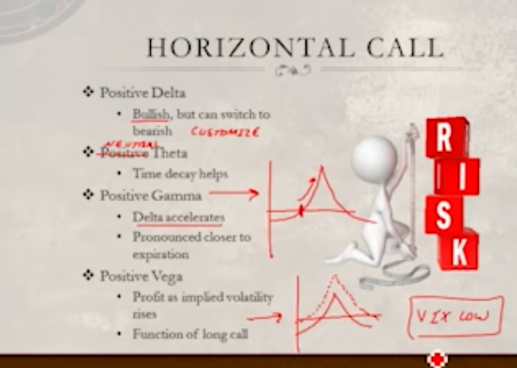

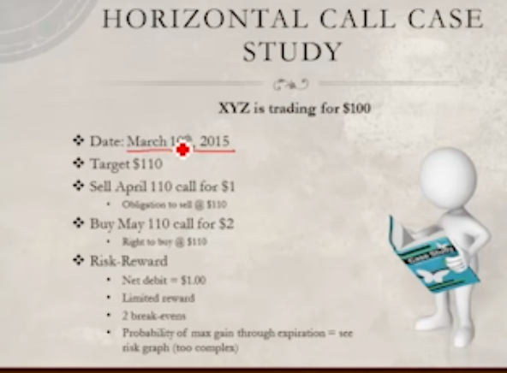

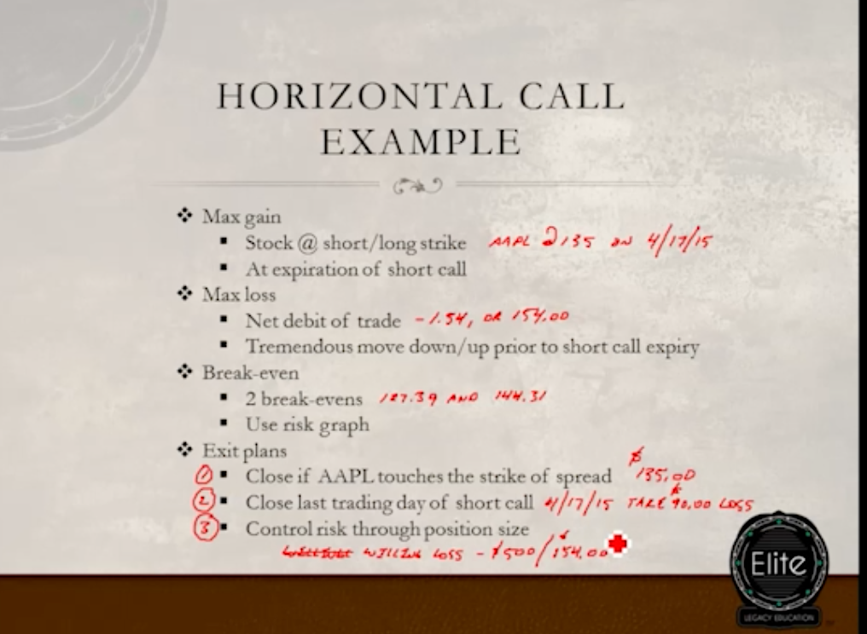

**Bear PUT diagonal calendar spread**

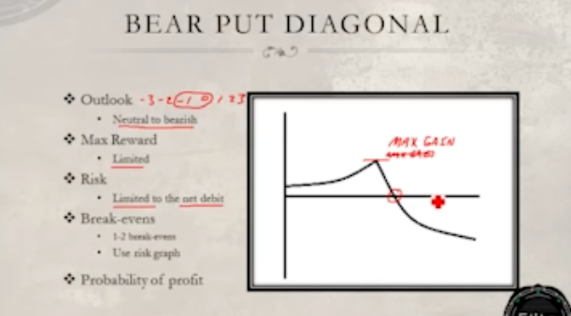

1. 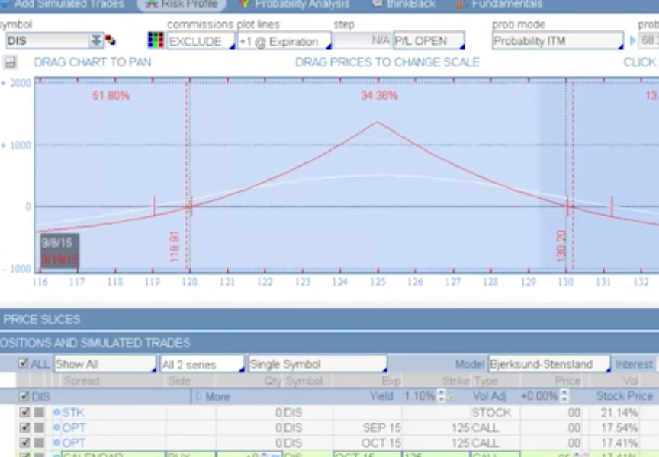

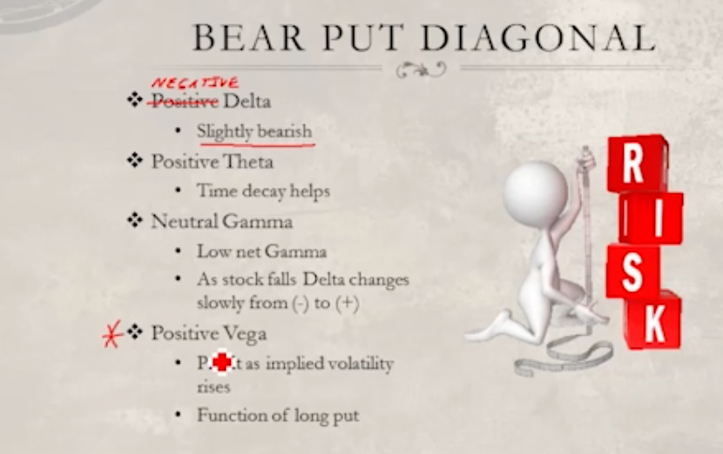

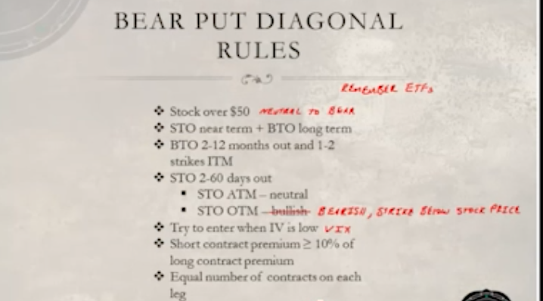

**Horizontal PUTs**

**Secret sauce of horizontal spreads is keep BTO and STO to keep costs minimal.**

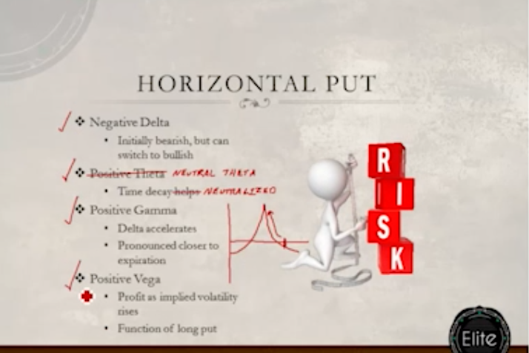

**Syntax:**

**Buy a PUT for 4-6 months time**

**Sell a PUT for near term for same strike**

1. **You can do ITM or OTM for bear PUTs.**
2. **Exit plan:**
   1. **Close the trade on sell expiry date. Check half way thru STO expiry**
3. **Position size = 500 / contract price**
4. **Catch is we don’t want stock to move to fast like within a week**
5. **While BULL CALL will still make money if stock moves within a week, HORIZONTAL CALL will result it into loss if stock moves in expected direction within a week. However, BULL CALL are expensive.**
6. **Most Aggressive to Least aggressive**

**Calls => Bull PUTs, Horizontal Call, Bull Call, Long Call**

**PUTs => Bear Call, Horizontal PUTs, Bear PUT, Long PUT**

**Neutral => Iron Condor, Short Strangle, Iron Butterfly**

**Bi-Directional => Inverted Butterfly, Long Straddle, Long Strangle**

**PUT / CALL Parity**

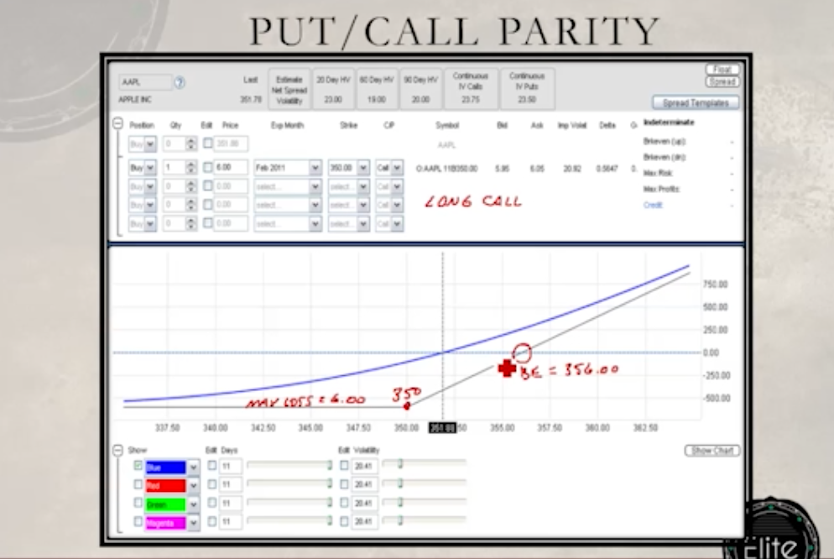

**Buy/Long Call = Buy/Long PUT + 100 stocks**

**Though the above equation is right, its essential to buy PUTs on 401K stocks to make the downside protected and make money while things are dropping. In the worst case, PUTs pay and we still have stocks. It’s a no brainer. Mistake commonly done is stock is so good it cannot go down from here. AABA and BABA are examples of same wrong confidence. Never succumb to friends comments / blabbering. Stick to own analysis.**

**Some trades are synthesized / masked versions of other trades. Put your eyes and brain open.**

**Bullish Risk Reversal**

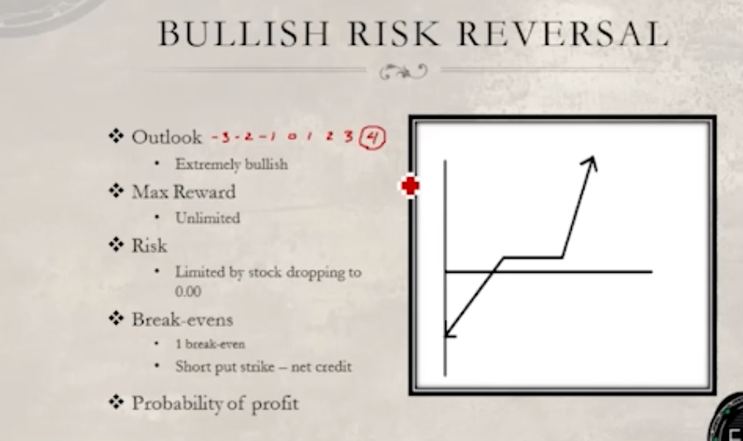

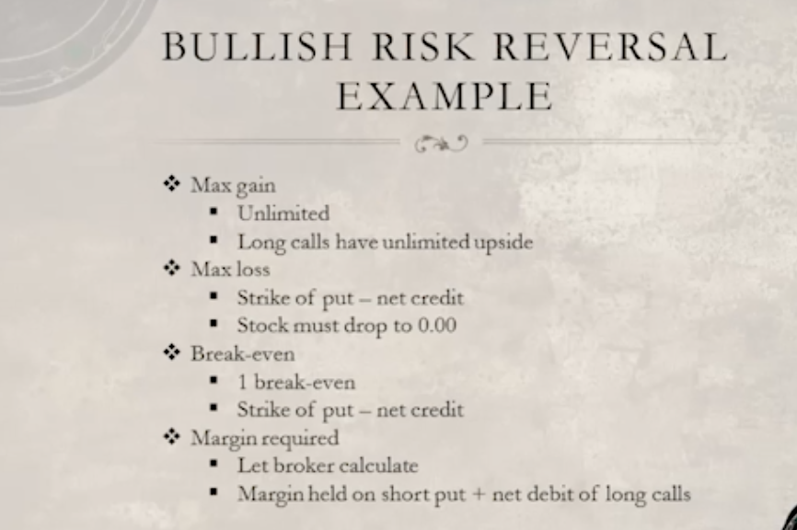

1. **Above is just like Sell PUTs if the stock tanks. So not very enticing if the stock can tank.**
2. **Reevaluation of trade thru its life is important. Half way in the expiry, if its not moving in expected, you may want to close**
3. **Longer we wait, harder it becomes to win the trade**
4. **If stock touches to make sell PUT worthless, BTC the short PUT. Set a stop loss for that to automate this. Good thing is you can still leave the calls as is that come for free.**

**Risk Management**

1. **Winning million dollars in fluke may happen. But if we randomly bet small amounts out of that million again and again, chances are that casino / market will win.**
2. **Make a system and process and stick to it. Don’t change rules in the middle of the game. Ask any sincere kid. They will say YES.**

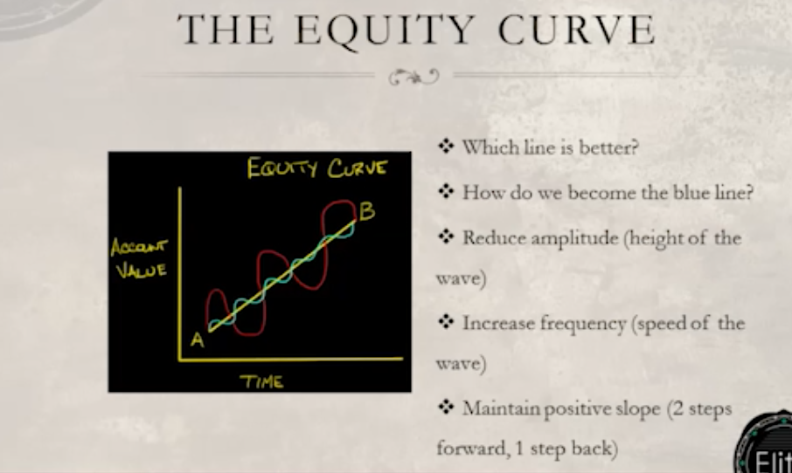

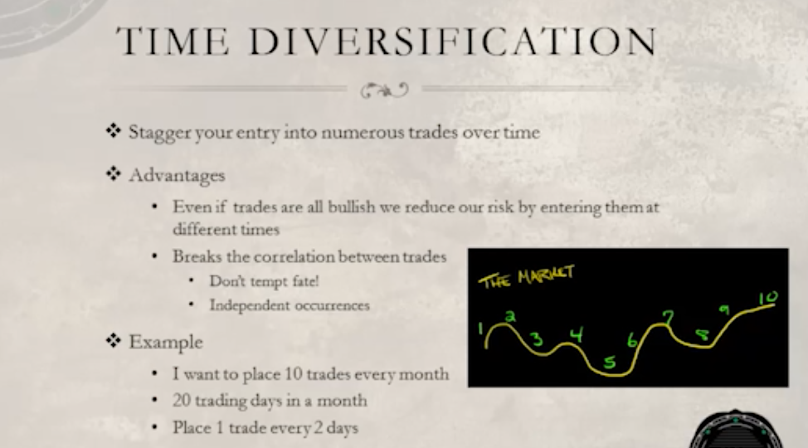

1. **We will be able to catch the market trends when we place trades on different days and times. If we place too many / too big trade on same day, you have chance of missing lows and highs.**
2. **Don’t go just go bullish. Keep it combo.**

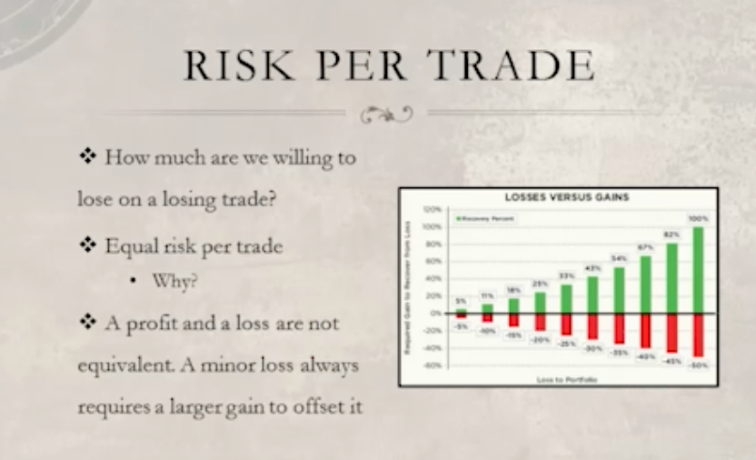

1. **If we loose 50%, we need 100% gain to make it back. That should speak volume about importance of stop losses. Don’t run across freeway blind folded.**
2. **Following sums up Dhoni style. Compounding over lot of small wins makes it large given patience. Remember, 50% loss needs 100% gain to make it Warren Buffet Rule of Break Even. Don’t loose money is rule 1 and rule 2 is concur with rule 1.**



**Contact Micah Brooks at** [**plentyoftrades@gmail.com**](mailto:plentyoftrades@gmail.com)**.**